FINDING THE PLASMA DONOR

A
Mini Project Report

Submitted in partial fulfilment of the Requirements for the award of the Degree of
BACHELOR OF ENGINEERING

IN

INFORMATION TECHNOLOGY

By

ASWINI – 1602-19-737-068
SAI SRAGVI – 1602-19-737-098


Department of Information Technology Vasavi College of Engineering (Autonomous) (Affiliated to Osmania University) Ibrahimbagh, Hyderabad-31 202
Vasavi College of Engineering (Autonomous) (Affiliated to Osmania University)
2020

Hyderabad-500 031 Department of Information Technology

DECLARATION BY THE CANDIDATE

We, M ASHWINI and SAI SRAGVI bearing hall ticket numbers, 1602-19-737-068 and 1602-19-737-098 respectively, hereby declare that the project report entitled “FINDING THE PLASMA DONOR” is submitted in partial fulfillment of the requirement for the award of the degree of Bachelor of Engineering in Information Technology.

This is a record of bonafide work carried out by us and the results embodied in this project report have not been submitted to any other university or institute for the award of any other degree or diploma.

ASHWINI – 1602-19-737-068
SAI SRAGVI– 1602-19-737-098

(Faculty In-Charge) (Head, Dept. of IT)

AKNOWLEDGEMENTS

Our Mini Project would not have been successful without the help of several people. We are extremely thankful to our college, Vasavi College of Engineering, for providing the opportunity to implement our project, “ FINDING THE PLASMA DONOR”.
We would like to express our gratitude to Ms. Prasanna, Assistant Professor, Department of Information Technology, Vasavi College of Engineering and Dr. Ramesh Vasappanavara, Professor, Department of Information Technology, Vasavi College of Engineering, for their esteemed guidance, moral support and invaluable advice provided by them for the success of the Mini Project.
Sincerely,

M ASHWINI - 1602-19-737-068

SAI SRAGVI- 1602-19-737-098

ABSTRACT

*THIS IS THE REAL TIME PROJECT INSPIRED BY THE CURRENT SITUATION
*IF A DONNIE NEEDS A PLASMA WE WILL PROVIDE THEM A DONOR LIST ,BY MATCHING THEIR BLOOD GROUP

TABLE OF CONTENTS
- Introduction………………...............................................6
- Technology………………………………………………9
- Proposed Work…………………………………………9
3.1Design………………………………………………..10
3.2 Implementation…………………………………….12
3.3Testing……………………………………………..28
3.3.1 Tetst Plan…………………………….28
3.3.2 Use Cases……………………………29
- Results…………………………………………………33
- Additional Knowledge Acquired………………………43
- Conclusion and Future Work………………………….44
- References…………………………………………….45

INTRODUCTION

ABOUT THE PROJECT
“FINDING THE PLASMA DONOR” is a C Project, which is based on the current situation. We all know the important of plasma who are suffering from COVID-19 , our project is mainly about finding the people who are interested to donate plasma .

1.1 PROJECT DOMAIN

During the current Covid-19 Situation patient suffering with virus needs plasma. Our main intention is to provide plasma for those patients .We collect the details of the donors who ever are interested to donate the plasma so that they can donate plasma to the people in need.
Purpose
The Main aim of developing this project is to find the donors who are interested and applicable to donate plasma .
Benefits
There is no project based on finding plasma. So the donee benefits by getting donor list from this project, Donor Details are stored in our records.
1.2 FEATURES
We added extra features like Checking the eligibility conditions for Donor to donate Plasma. We also find the match by not only matching similar blood groups but also match the eligible matches.

TECHNOLOGY
All computer software needs certain hardware components or other software resources to be present, in order for computers to be used efficiently. These prerequisites are known as System Requirements. Within this, we have two types – Software Requirements and Hardware Requirements.

SOFTWARE REQUIREMENTS
Software Requirements deal with defining the software resource requirements and prerequisites that need to be installed on a computer to provide optimal functioning of an application. These preconditions are generally not included in the software installation package and need to be installed separately.
In order to use CODIAC, one should have the following:

- Operating System: Windows 7 and above
- C Compiler: GNU Compiler Collection (GCC)
- Editor: Any text editor .

HARDWARE REQUIREMENTS
Hardware requirements refer to the common set requirements defined by any operating system or software application and are usually the physical computer resources. In this, we look into the architecture, processing power, memory, secondary memory, display adapter and peripherals.
In order to use this project, one should have the following:

    - Processor: Intel Pentium processor and above
    - Memory: 4 GB RAM and above

- PROPOSED WORK
3.1 DESIGN
To reduce the pen and paper work we designed our project through online.

3.2 IMPLEMENTATION
Based on the use cases, we have implemented this project by dividing the work into modules – Register,donor,check eligibility, add donor , Donee add donee search donor , display donor, delete donor.
USE CASES
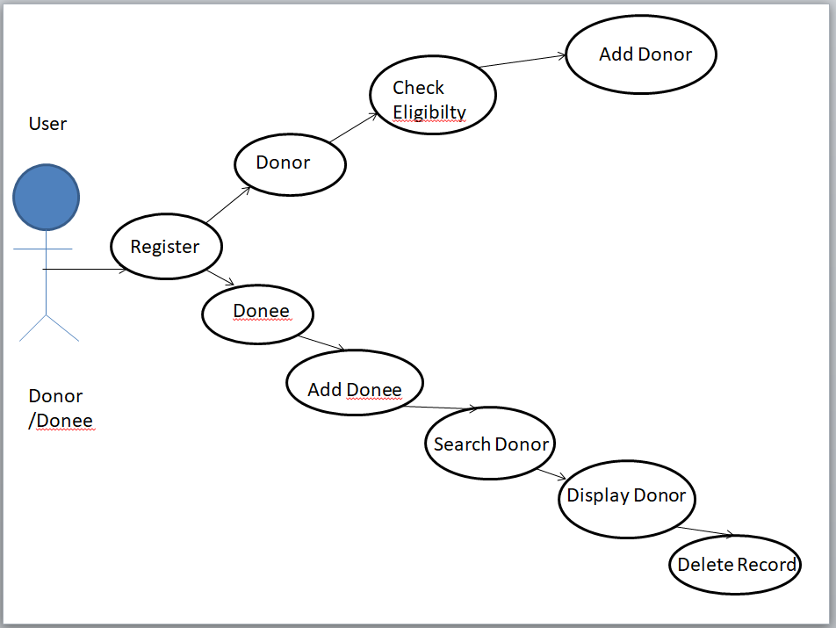
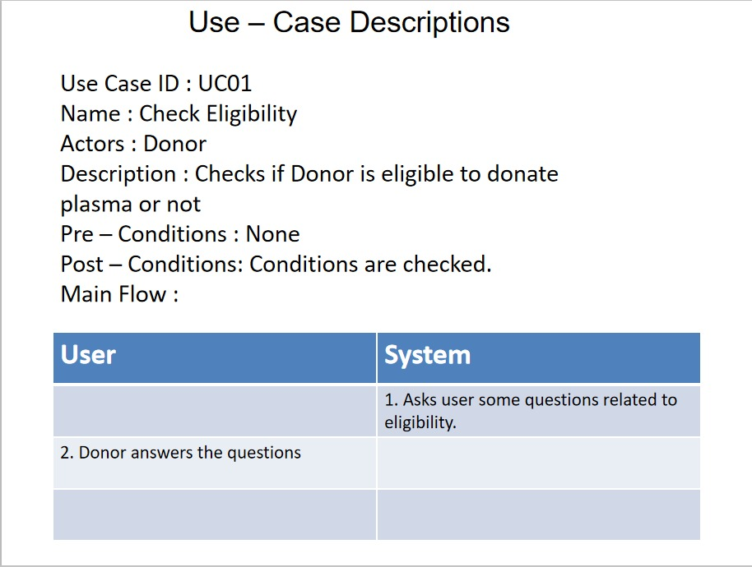
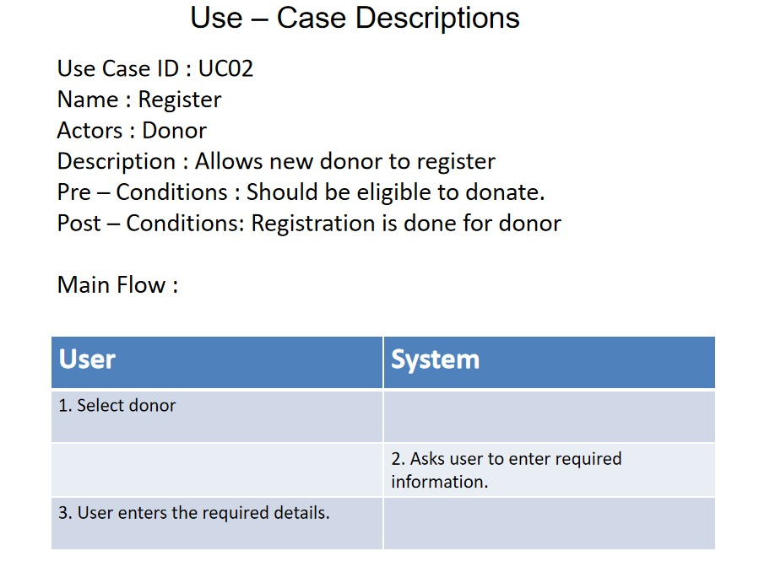

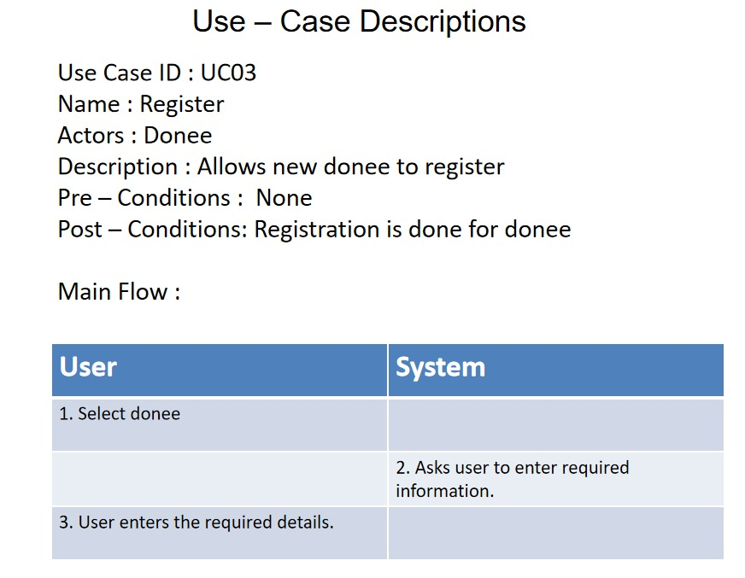
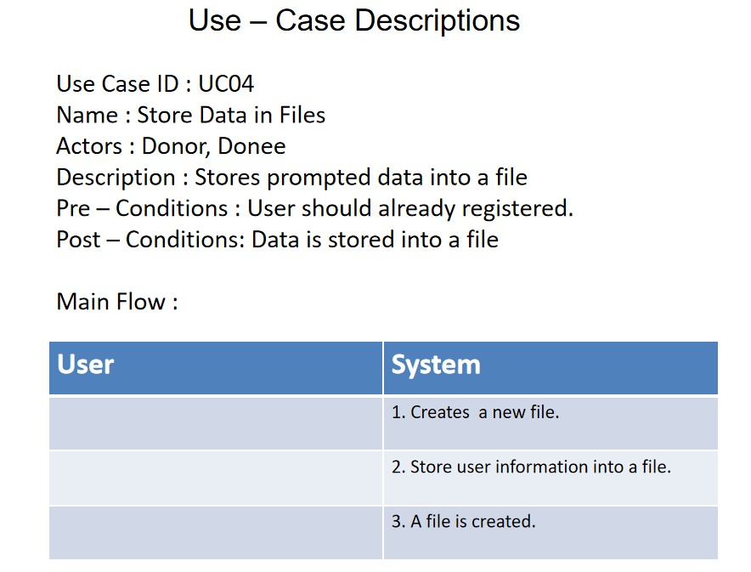
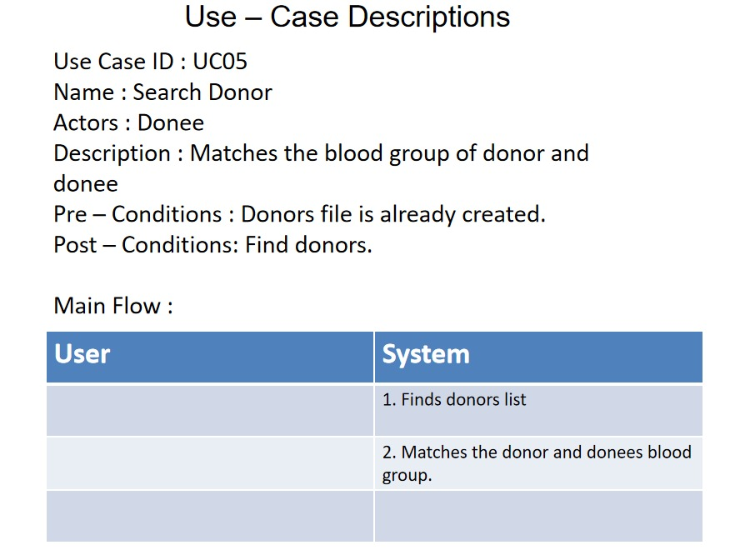
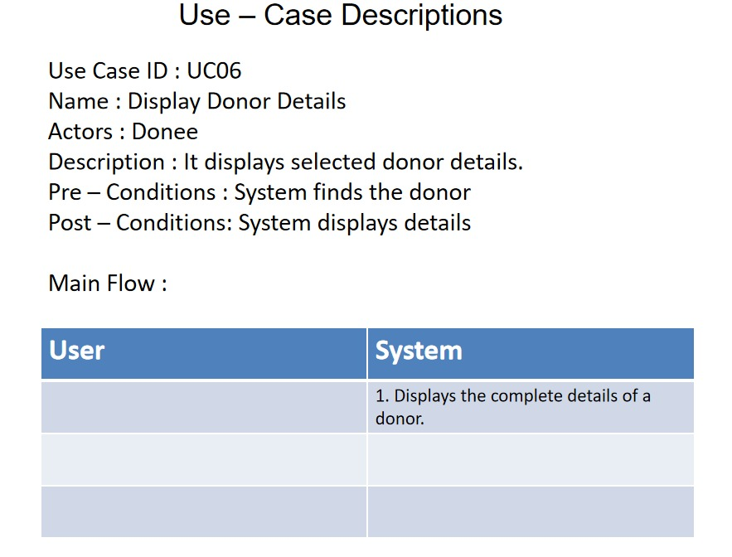
FLOW CHART
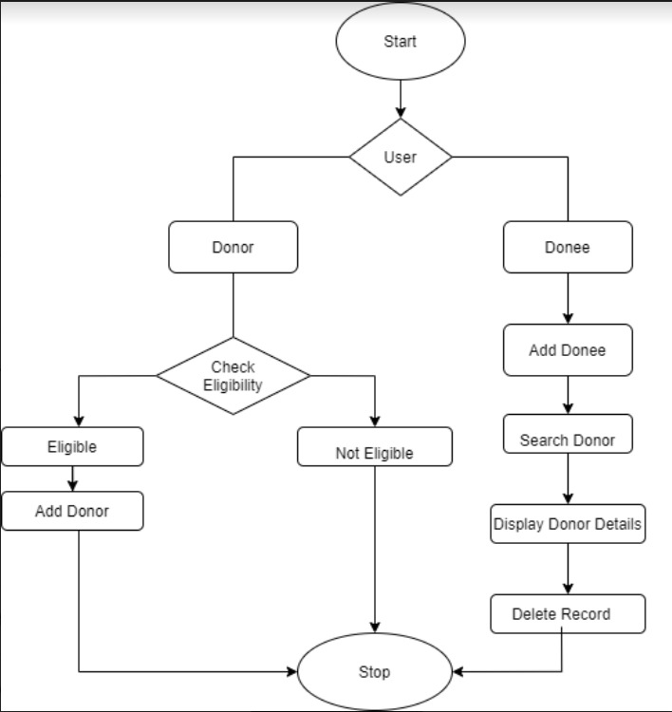

#include<stdio.h>
#include<stdlib.h>
#include<string.h>
#include<ctype.h>
#include<windows.h>
#include<errno.h>
#include<unistd.h>

struct User
{
char name[25];
char blood_group[3];
char gender;
char phone_number[10];
char add[100];
};//Donor,Donee

void AddDonor();
void DoneeDetails();
void SearchDonor(char blood_group[3]);
void DisplayDetails(int line);
void DeleteRecord(int line);
int CheckPhoneNumber(char num[10]);

int main()
{
system("cls");
system("color 4e");
int opt;
char blood_group[3];
printf("\n\t\t\t=======================================");
printf("\n\t\t\t=======================================");
printf("\n\t\t\t| WELCOME TO PLASMA DONATING SYSTEM |");
printf("\n\t\t\t=======================================");
printf("\n\t\t\t=======================================");
printf("\n\n");
//System(clr);
printf("\n\t\t *");
printf("\n\t\t ***");
printf("\n\t\t *****");
printf("\n\t\t *******");
printf("\n\t\t *********");
printf("\n\t\t ***********");
printf("\n\t\t *************");
printf("\n\t\t ***************");
printf("\n\t\t *****************");
printf("\n\t\t ***************");
printf("\n\t\t *************");
printf("\n\t\t ***********");
printf("\n\t\t *******\n");
system("pause");
system("cls");
system("color 2e");
printf("\t\tAre u a Donor or Donee?\n\t\tIf Donor enter 1 or If Donee enter 2 : ");
scanf("\t\t%d",&opt);
system("pause");
system("cls");
system("color 3e");
if(opt==1)
{
char ans[3],c,check;
int wgt;
printf("\n\n");
printf("\n\n\n\t\tPlease answer some Elgibilty Questions :-\n");
printf("\n\n\t\tIs your age is between 18 to 65 years?\n\t\tEnter y-yes / n-no :");
scanf(" %c",&ans[0]);
printf("\n\t\tAre you a woman or men?\n\t\tEnter w-women / m-men : ");
scanf(" %c",&check);
if(toupper(check)=='W')
{
char c;
printf("\n\t\tIf you are married, do you have kids or you are pregnant? (Enter n-no if you are unmarried)\n\t\tEnter y-yes / n-no : ");
scanf(" %c",&c);
if(toupper(c)=='Y')
{
goto line1;
}
ans[1]='y';
}
if(toupper(check)=='M')
{
ans[1]='y';
}
printf("\n\t\tDid you tested -ve for the virus atleast 14 days from now? \n\t\tEnter y-yes / n-no : ");
scanf(" %c",&ans[2]);
printf("\n\t\tEnter your weight in kgs : ");
scanf("%d",&wgt);
int val=1;
for( int i=0;i<3;i++)
{
if(ans[i]=='y')
continue;
else
val=0;
break;
}
if(val==1 && wgt>=55)
{

//AddDonor
printf("\n\n\t\t*****************************************");
printf("\n\t\t| YOU ARE ELIGIBLE TO DONATE PLASMA!!!! |");
printf("\n\t\t*****************************************\n");
system("pause");
system("cls");
system("color 4e");
printf("\n\t\tENTER YOUR DETAILS :-\n\n");
AddDonor();
printf("\n\n\n\n\n\t\t=======================================================");
printf("\n\t\t---------------THANK YOU FOR REGISTERING---------------");
printf("\n\t\t=======================================================");

}
else
{
line1:printf("\n\t\t-----------------------------------------------------");
printf("\n\t\t-----------------------------------------------------");
printf("\n\t\t| SORRY, YOU ARE NOT ELIGIBLE FOR DONATING PLASMA!! |");
printf("\n\t\t-----------------------------------------------------");
printf("\n\t\t-----------------------------------------------------");
}
}
else if(opt==2)
{
DoneeDetails();
}
return 0;
}

void AddDonor()
{
struct User d;
FILE *fptr=fopen("Donor.txt","a");
fflush(stdin);
printf("\n\t\tYOUR BLOOD GROUP(Eg : AB+) : ");
gets(d.blood_group);
/*char bg[3];
strcpy(bg,d.blood_group);

while(strupr(bg)!="O+" || strupr(bg)!="O-" || strupr(bg)!="A+" || strupr(bg)!="A-" || strupr(bg)!="B+" || strupr(bg)!="B-" || strupr(bg)!="AB+" || strupr(bg)!="AB-")
{
if(strupr(bg)=="O+" || strupr(bg)=="O-" || strupr(bg)=="A+" || strupr(bg)=="A-" || strupr(bg)=="B+" || strupr(bg)=="B-" || strupr(bg)=="AB+" || strupr(bg)=="AB-")
{
break;
}
printf("first----%s...",strupr(bg));
printf("\n\t\tYOUR BLOOD GROUP(Eg : AB+) : ");
gets(d.blood_group);
strcpy(bg,d.blood_group);
printf("second----%s...",strupr(bg));
}*/
if(strlen(d.blood_group)==3)
fprintf(fptr,"%c%c%c ",toupper(d.blood_group[0]),toupper(d.blood_group[1]),d.blood_group[2]);
else if(strlen(d.blood_group)==2)
fprintf(fptr,"%c%c ",toupper(d.blood_group[0]),d.blood_group[1]);

printf("\n\t\tYOUR FULLNAME : ");
gets(d.name);
fprintf(fptr,"%s ",d.name);
for(int i=1;i<=25-strlen(d.name);i++)
{
fprintf(fptr," ");
}
printf("\n\t\tYOUR GENDER(M-Male or F-Female) : ");
scanf("%c",&(d.gender));
/*while(toupper(d.gender)!='M' || toupper(d.gender)!='F')
{
printf("\n\t\tYOUR GENDER(M-Male or F-Female) : ");
scanf("%c",&(d.gender));
}*/
fprintf(fptr,"%c ",d.gender);
fflush(stdin);
printf("\n\t\tYOUR ADDRESS : ");
gets(d.add);
fprintf(fptr,"%s ",d.add);
for(int i=0;i<100-strlen(d.add);i++)
{
fprintf(fptr," ");
}
line:printf("\n\t\tYOUR PHONE NUMBER : ");
fflush(stdin);
scanf("%s",d.phone_number);
if(CheckPhoneNumber(d.phone_number))
fprintf(fptr,"%s\n",d.phone_number);
else
{
printf("\t\tENTER CORRECT PHONE NUMBER!!!!");
goto line;
}
fclose(fptr);
}

int CheckPhoneNumber(char num[10])
{
//printf("Yes");
if(strlen(num)!=10)
{
return 0;
}
int i=0;
while(i<10)
{
if(isdigit(num[i]))
{
i++;
continue;
}
else
return 0;

}
if(num[0]=='9' || num[0]=='8' || num[0]=='7' || num[0]=='6')
{
return 1;
}
return 0;
}

void DoneeDetails()
{
struct User d;
FILE *fptr=fopen("Donee.txt","a");
fflush(stdin);
printf("\n\t\tENTER YOUR DETAILS :-\n");
printf("\n\t\tYOUR BLOOD GROUP(Eg : AB+) : ");
gets(d.blood_group);
/*char bg[3];
bg[0]=toupper(d.blood_group[0]);
bg[1]=toupper(d.blood_group[1]);
bg[2]=toupper(d.blood_group[2]);
while(bg!="O+" || bg!="O-" || bg!="A+" || bg!="A-" || bg!="B+" || bg!="B-" || bg!="AB+" || bg!="AB-")
{
printf("\n\t\tYOUR BLOOD GROUP(Eg : AB+) : ");
gets(d.blood_group);
char bg[3];
bg[0]=toupper(d.blood_group[0]);
bg[1]=toupper(d.blood_group[1]);
bg[2]=toupper(d.blood_group[2]);
}*/

if(strlen(d.blood_group)==3)
fprintf(fptr,"%c%c%c ",toupper(d.blood_group[0]),toupper(d.blood_group[1]),d.blood_group[2]);
else if(strlen(d.blood_group)==2)
fprintf(fptr,"%c%c ",toupper(d.blood_group[0]),d.blood_group[1]);

printf("\n\t\tYOUR FULLNAME : ");
gets(d.name);
fprintf(fptr,"%s ",d.name);
for(int i=1;i<=25-strlen(d.name);i++)
{
fprintf(fptr," ");
}
printf("\n\t\tYOUR GENDER(M-Male or F-Female) : ");
scanf("%c",&(d.gender));
/*while(toupper(d.gender)!='M' || toupper(d.gender)!='F')
{
printf("\n\t\tYOUR GENDER(M-Male or F-Female) : ");
scanf("%c",&(d.gender));
}*/

fprintf(fptr,"%c ",d.gender);
fflush(stdin);
printf("\n\t\tYOUR ADDRESS : ");
gets(d.add);
fprintf(fptr,"%s\n",d.add);
for(int i=0;i<100-strlen(d.add);i++)
{
fprintf(fptr," ");
}
line:printf("\n\t\tYOUR PHONE NUMBER : ");
fflush(stdin);
scanf("%s",d.phone_number);
if(CheckPhoneNumber(d.phone_number))
fprintf(fptr,"%s\n",d.phone_number);
else
{
printf("\t\tEnter correct phone number!!!!\n");
goto line;
}
fclose(fptr);
SearchDonor(d.blood_group);
//return d.blood_group;
}

void SearchDonor(char blood_group[3])
{
system("pause");
system("cls");
system("color 6e");
FILE *fptr=fopen("Donor.txt","r");
char str[2],ch,c;
int line=1;
while((ch=getc(fptr))!=EOF)
{

fscanf(fptr,"%s",str);
if(ch=='O' && str[0]=='-')
{
printf("\n\t\tFOUND THE MATCH!!!");
printf("\n\n\t\tDETAILS : \n");
DisplayDetails(line);
break;
}
else if(ch=='O' && str[0]=='+')
{
if(blood_group[1]=='+' || blood_group[2]=='+')
{
printf("\n\t\tFOUND THE MATCH!!!");
printf("\n\n\t\tDETAILS : \n");
DisplayDetails(line);
break;
}
}
else if(ch=='A' && str[0]=='-')
{
if(blood_group[0]=='A')
{
printf("\n\t\tFOUND THE MATCH!!!");
printf("\n\n\t\tDETAILS : \n");
DisplayDetails(line);
break;
}
}
else if(ch=='A' && str[0]=='+')
{
if((blood_group[1]=='+' || blood_group[2]=='+') && blood_group[0]=='A' )
{
printf("\n\t\tFOUND THE MATCH!!!");
printf("\n\n\t\tDETAILS : \n");
DisplayDetails(line);
break;
}
}
else if(ch=='B' && str[0]=='-')
{
if(blood_group=="B+" || blood_group=="AB+" || blood_group=="AB-" || blood_group=="B-")
{
printf("\n\t\tFOUND THE MATCH!!!");
printf("\n\n\t\tDETAILS : \n");
DisplayDetails(line);
break;
}
}
else if(ch=='B' && str[0]=='+')
{
if(blood_group=="AB+" || blood_group=="B+")
{
printf("\n\t\tFOUND THE MATCH!!!");
printf("\n\n\t\tDETAILS : \n");
DisplayDetails(line);
break;
}
}
else if(ch=='A' && str=="B-")
{
if(blood_group=="AB+" || blood_group=="AB-")
{
printf("\n\t\tFOUND THE MATCH!!!");
printf("\n\n\t\tDETAILS : \n");
DisplayDetails(line);
break;
}
}
else if(ch=='A' && str=="B+")
{
if(blood_group=="AB+")
{
printf("\n\t\tFOUND THE MATCH!!!");
printf("\n\n\t\tDETAILS : \n");
DisplayDetails(line);
break;
}
}
c=getc(fptr);
while(c!='\n')
{
if(c==EOF)
break;
c=getc(fptr);
}
line++;
if(c==EOF)
break;
}
if(ch==EOF || c==EOF)
{
printf("\n\n\t\t=============================");
printf("\n\t\tSORRY MATCH NOT FOUND :( !!!!");
printf("\n\t\t=============================");
}
fclose(fptr);
}

void DisplayDetails(int line)
{
FILE *fptr=fopen("Donor.txt","r");
char blood_group[3],name[25],gender,phone_number[10],add[50];
int test=1;
char ch,c;
while((ch=getc(fptr))!=EOF)
{
if(test==line)
{
int i=1;
printf("\n\t\tBLOOD GROUP : ");
do{
printf("%c",ch);
ch=getc(fptr);
i++;
}while(i<=3);
//ch=getc(fptr);
printf("\n\t\tNAME : ");
for(int i=0;i<25;i++)
{
ch=getc(fptr);
printf("%c",ch);
}
ch=getc(fptr);
ch=getc(fptr);
printf("\n\t\tGENDER : %c",ch);
ch=getc(fptr);
printf("\n\t\tADDRESS : ");
for(int i=0;i<100;i++)
{
ch=getc(fptr);
printf("%c",ch);
}
ch=getc(fptr);
printf("\n\t\tPHONE NUMBER : ");
for(int i=0;i<10;i++)
{
ch=getc(fptr);
printf("%c",ch);
}
DeleteRecord(line);
break;
}
c=getc(fptr);
while(c!='\n' && c!='\0')
{
c=getc(fptr);
}
test++;
}
fclose(fptr);
}

void DeleteRecord(int line)
{
char c;
int temp=1;
FILE *fptr1=fopen("Donor.txt","r");
FILE *fptr2=fopen("Temp.txt","w");
c=getc(fptr1);
if(line==1)
{
while(c!='\n')
{
c=getc(fptr1);
}
while((c=getc(fptr1))!=EOF)
{
putc(c,fptr2);
}
}
else
{

if(temp!=line)
{
putc(c,fptr2);
}
while(c!=EOF)
{
c=getc(fptr1);
if(c=='\n')
{
temp++;

}
if(temp!=line)
{
putc(c,fptr2);
}
}
}
fclose(fptr1);
fclose(fptr2);
remove("Donor.txt");
rename("temp.txt", "Donor.txt");
printf("\n\t\tRECORD DELETED");
}

3.3TESTING

Testing is a method to check whether the actual product matches the expected requirements and to ensure that the product is defect-free. This process involves execution of various parts of the product either using manual or automated tools. The purpose is to identify errors, gaps or missing requirements in contrast to the actual requirements.

3.3.1TEST PLAN
We approached testing our console application by analysing each module separately. First, we coded the requirements and then manually tested each feature present in the module to cover any gaps that might occur.
3.3.2USER TEST CASES
Our user has - Register,donor,check eligibility, add donor , Donee add donee search donor , display donor, delete donor.

RESULTS
Test Case - 1:

Description : If user is a Donor and user is not eligible to donate Plasma

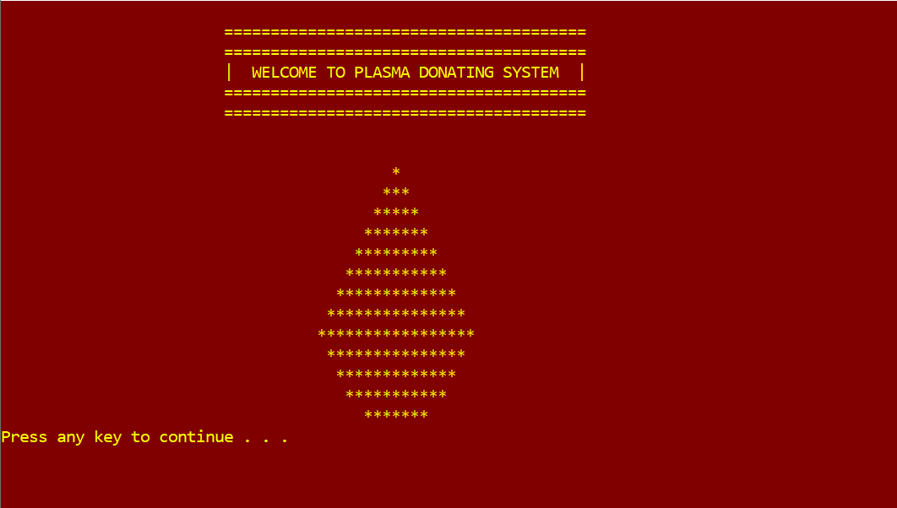

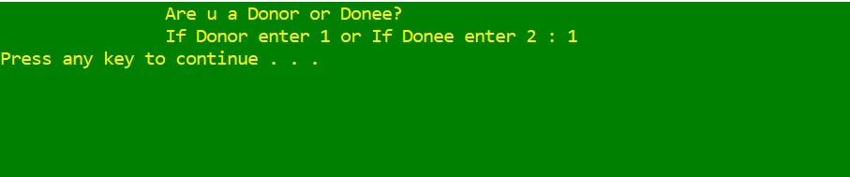
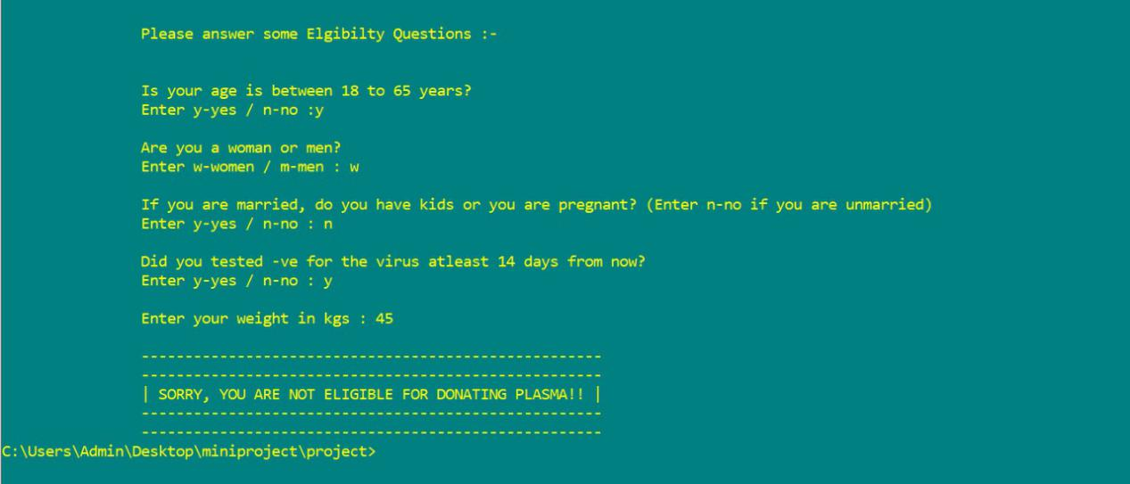
Test Case - 2:
Description : If user is a Donor and eligible to donate Plasma
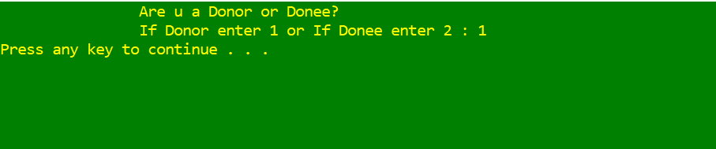
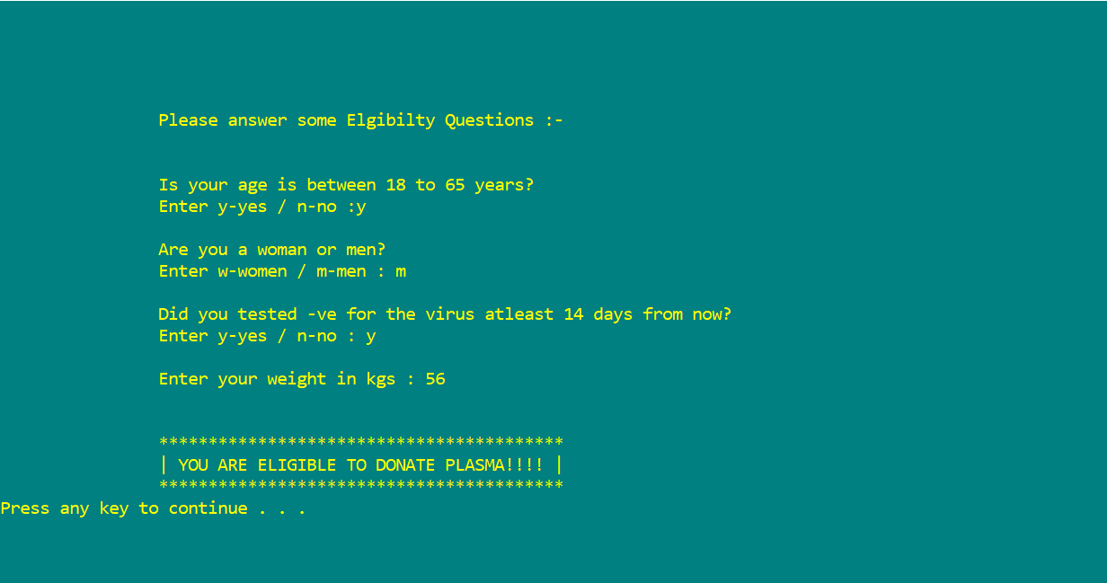
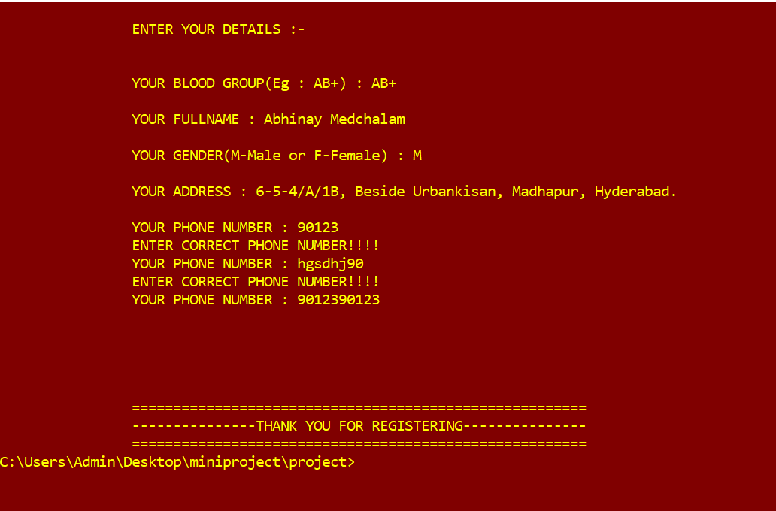
Test Case - 3:
Description : If user is a Donee and Match found.
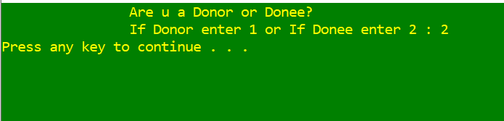
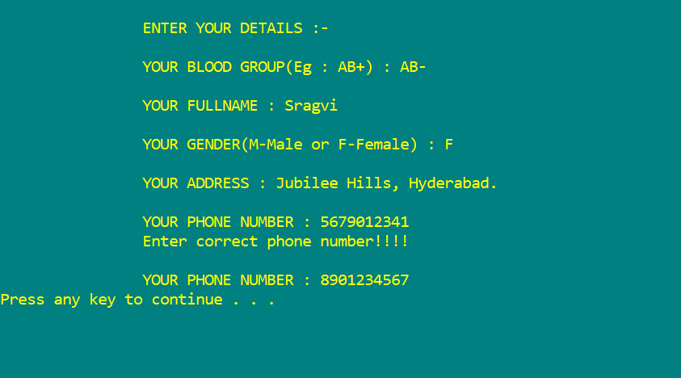
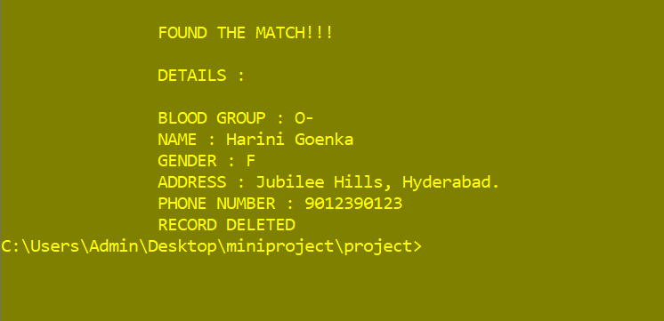
Test Case - 4:
Description : If user is a Donee and Match not found
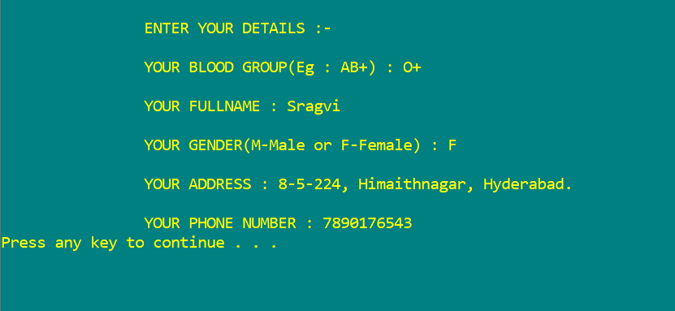
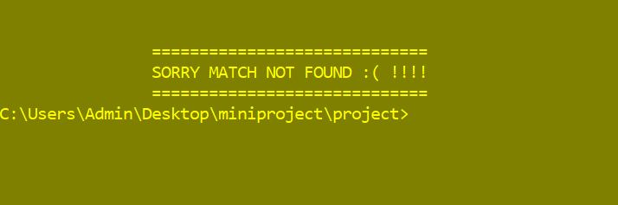

5.ADDITIONAL KNOWLEDGE ACQUIRED

Implementing this project in C Language has introduced us to different libraries such as: ‘conio.h’, ‘errno.h’ and ‘windows.h’. We were able to use the knowledge we have on the Linked List Data Structure and execute it as a real-time application. We used the ‘windows.h’ library for controlling the display colours in a controlled manner. We explored the ‘errno.h’ and ‘conio.h’ libraries for achieving a look-and-feel of an actual window application by constructing our own time delay function.
Also, we have further improved in our knowledge in file-handling because of the vast amount of data manipulation we have done using text files.
Other than this, we have learnt the value of team spirit and have understood the intention behind working in teams. We have learnt to be team players

6.CONCLUSION AND FUTURE WORK
This project is not only useful for Students but also Hospital Management. This will helpful to find the Donor.
In future we are planning to improve it by updating a feature like tracking Donors location and accessible by donee, so that donee can easily find the Donor.

7. REFERENCES
- Visual Studio Code
- Gvim editor
- Stack Overflow (for debugging errors): https://stackoverflow.com/
- Online gdb

3.2.2. GitHub Folder/ Structure
We have segregated the files of our project into folders namely - Code and Files. Code folder contains the main C file and the Files folder contains the data files (.txt format) which we used in our project. Our repository also contains a README file which has a brief description of our project. We have also uploaded report of our project on our github repository.
Git-hub Links:
Ashwini-068
https://github.com/ashu025/Mini-Project1
Sragvi-098
https://github.com/Sragvi13/Mini_project1

